**Requirements Specification**

Integrating Digital and Traditional Marketing

|  |  |  |  |  |  |  |  |  |  |  |  |  |
| --- | --- | --- | --- | --- | --- | --- | --- | --- | --- | --- | --- | --- |
| Revision History   |  |  |  |  | | --- | --- | --- | --- | | **Name** | **Date** | **Remarks** | **Version** | | 6 Sigma Samurais | 30/03/18 | Initial Requirements Specification | 1 | | 6 Sigma Samurais | 08/07/18 | Final Version | 2 | |

*© Bill Manos* – *CONFIDENTIAL*

**Table of Contents**

Background information 3

Vocabulary/abbreviations/conventions 3

Product overview 3

Team Members and responsibilities 5

Target market and users 5

Detailed product description 6

Content / Data 6

Software 7

**Back-office (editing and administration) tools** 8

**Payment system and user authentication** 8

**Adverts** 9

**Graphic design guidelines** 9

**Accessibility** 9

**Target platforms and configurations** 9

**Performance** 9

Testing and acceptance 9

Delivery medium and installation 10

Processes and logistics 10

Documentation and source code 10

Training 10

Schedule and milestones 10

Risks, dependencies and other issues 11

Project Screenshots 11

# Background information

The project aims to provide solution for marketing professionals for better decision making and to help develop marketing plans to maximize the impact and return on investment. The ownership of the project is held by EPITA, under the supervision of Bill Manos. To conduct research, analyze and provide a summary of the reasons behind the trends in market.

# Vocabulary/abbreviations/conventions

**Datasets:** A collection of data that provides information.

**Omnichannel:** Omnichannel is a cross-channel business model and content strategy that companies use to improve their user experience.

**Meta-physical:** Here we are talking about the products which can be marketed, digital and physical marketing in synchronization.

**CSV:** A comma-separated values (CSV) file is a delimited text file that uses a comma to separate values. A CSV file stores tabular data (numbers and text) in plain text. Each line of the file is a data record. Each record consists of one or more fields, separated by commas.

**Representational State Transfer (REST):** is an architectural style that defines a set of constraints to be used for creating web services. Web Services that conform to the REST architectural style

**Python Packages:** A package is a special arrangement of the folder plus modules to enable a particular functionality.

# Product overview

The Project is based on omnichannel marketing trends that combine traditional/physical and digital marketing. Analyze the reasons and demographics for the growing interest and return of analog technologies, such as printed books, vinyl records and printed photos (i./e. HP Sprocket). Provide feedback and ideas of what marketers need to consider when developing marketing plans to maximize the impact and return on investment.

The propose system is an extension of “pytrend” with a graphical user interface that allow user to predict an estimation of which will profitable to run a digital or non-digital operation to establish a new business. It is a desktop application that using google APIs to crawling data set online and provides set of matching information base on the search key word that should be input. This application and analysis tool with many features.

Based on the analysis of the inputs given by user, our software will provide feedback and ideas for the potential marketers to prepare the market plans for their products

Based on the analysis, we will provide:

1)Age

2)Gender

3)Location

4)Occupation

5)Transportation

6)Activity

# Team Members and responsibilities

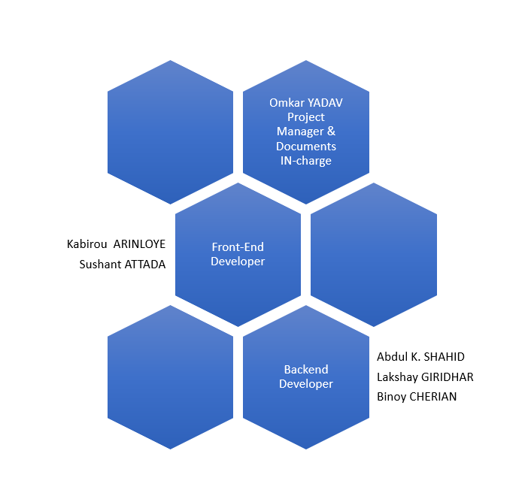

# Target market and users

The project is aimed at delivering market trends around the world for the marketing professional or a product owner intended. The project will address the potential clients for a product and provide detailed description in terms of age, gender, location in text and graphical format. User will also get a potential Go or No-Go decision based on the available dataset and input provided to the software. This project is intended to do basic decision making and provide set of recommendation.

# Detailed product description

## Content / Data

A desktop application that takes the following input from the user:

1. **Product Category:**

User will select relevant product category from the list, Art & Entertainment, Computer/Internet, Education, Food/Wine/Cooking and so on.

1. **Product Description:**

User will enter free text description of the products, our program will perform text mining to identify the patterns that will help in providing the trends.

1. **Type of the product:**

User will provide type of the product as Physical or Digital product.

1. **Online or Offline product:**

For digital platform, user will select if product features are accessible in offline mode (without internet connectivity).

1. **Location:**

For physical product, user will provide the location of store or manufacturing unit.

1. **Countries to market:**

User will select single/list country(s) to market the product.

Based on the provided inputs, the user will be able to fetch the following data trends

1. **Age:**

Based on the user input and result of the data mining algorithm, the software will able to provide a range of the age group would prefer to purchase the product.

1. **Gender:**

The software will be able to provide the gender of the avatar.

1. **Location:**

The software will be able to provide the geographical details.

1. **Occupation :**

The software will be able to provide the occupation of the targeted market.

1. **Transportation:**

The software will be able to provide the mode of transportation that would be preferred for the targeted market.

1. **Activities:**

The software will be able to provide activities done by the targeted market.

## Software

* **NumPy** stands for Numerical Python. The most powerful feature of NumPy is n-dimensional array. This library also contains basic linear algebra functions, Fourier transforms, advanced random number capabilities and tools for integration with other low-level languages like Fortran, C and C++.
* **SciPy** stands for Scientific Python. SciPy is built on NumPy. It is one of the most useful library for variety of high level science and engineering modules like discrete Fourier transform, Linear Algebra, Optimization and Sparse matrices.
* **Matplotlib** for plotting vast variety of graphs, starting from histograms to line plots to heat plots. You can use Pylab feature in ipython notebook (ipython notebook –pylab = inline) to use these plotting features inline. If you ignore the inline option, then pylab converts ipython environment to an environment, very similar to Matlab. You can also use Latex commands to add math to your plot.
* **Pandas** for structured data operations and manipulations. It is extensively used for data munging and preparation. Pandas were added relatively recently to Python and have been instrumental in boosting Python’s usage in data scientist community.
* **Scikit Learn** for machine learning. Built on NumPy, SciPy and matplotlib, this library contains a lot of efficient tools for machine learning and statistical modelling including classification, regression, clustering and dimensionality reduction.
* **Stats models** for statistical modelling. Stats models is a Python module that allows users to explore data, estimate statistical models, and perform statistical tests. An

extensive list of descriptive statistics, statistical tests, plotting functions, and result statistics are available for different types of data and each estimator.

* **Seaborn** for statistical data visualization. Seaborn is a library for making attractive and informative statistical graphics in Python. It is based on matplotlib. Seaborn aims to make visualization a central part of exploring and understanding data.
* **Pycountry** To get the product trends from based on the Country, state and city.
* **Bokeh** for creating interactive plots, dashboards and data applications on modern web-browsers. It empowers the user to generate elegant and concise graphics in the style of D3.js. Moreover, it has the capability of high-performance interactivity over very large or streaming datasets.
* **Pytrends** Allows simple interface for automating downloading of reports from Google Trends. Main feature is to allow the script to login to Google on your behalf to enable a higher rate limit.
* **PyQt5** is a [Python](https://en.wikipedia.org/wiki/Python_(programming_language)) [binding](https://en.wikipedia.org/wiki/Language_binding) of the [cross-platform](https://en.wikipedia.org/wiki/Cross-platform) [GUI](https://en.wikipedia.org/wiki/GUI) toolkit [Qt](https://en.wikipedia.org/wiki/Qt_(toolkit)), implemented as a Python [plug-in](https://en.wikipedia.org/wiki/Plug-in_(computing)). PyQt is [free software](https://en.wikipedia.org/wiki/Free_software) developed by the [British](https://en.wikipedia.org/wiki/United_Kingdom) firm Riverbank Computing. It is available under similar terms to Qt versions older than 4.5; this means a variety of licenses including [GNU General Public License](https://en.wikipedia.org/wiki/GNU_General_Public_License) (GPL) and commercial license
* **Blaze** for extending the capability of NumPy and Pandas to distributed and streaming datasets. It can be used to access data from a multitude of sources including Bcolz, MongoDB, SQLAlchemy, Apache Spark, PyTables, etc. Together with Bokeh, Blaze can act as a very powerful tool for creating effective visualizations and dashboards on huge chunks of data.
* **Scrapy** for web crawling. It is a very useful framework for getting specific patterns of data. It has the capability to start at a website home url and then dig through web-pages within the website to gather information.
* **SymPy** for symbolic computation. It has wide-ranging capabilities from basic symbolic arithmetic to calculus, algebra, discrete mathematics and quantum physics. Another useful feature is the capability of formatting the result of the computations as LaTeX code.
* **Requests** for accessing the web. It works similar to the standard python library urllib2 but is much easier to code. You will find subtle differences with urllib2 but for beginners, Requests might be more convenient.
* **Tkinter** is a Python binding to the Tk GUI toolkit. It is the standard Python interface to the Tk GUI toolkit and is Python's de facto standard GUI.

**User Stories:**

1. As a user, I want to provide all the inputs in the input section, so I can see the plots and the recommendation for my product.
2. As a user, I want to navigate among tabs, so that I can see the result in the formats of the graphs.
3. As a user, I want to navigate to recommendation tab, so that I can be able to see the suggestions for physical or digital marketing.
4. As a user, I want to navigate to recommendation tab, so that I can be able to see corresponding avatar suggestions.
5. As a user, I want to generate a document containing all the results, so that all the results will be downloaded into single file.

## **Back-office (editing and administration) tools**

The user must answer a series of questions, i.e. the input to the program, the input fields will be a text box or drop-down and the user does not require to install any editing tools.

## **Payment system and user authentication**

Payment system and user authentication is not in the scope of development.

## **Adverts**

Website monetization is not in the scope of development.

## **Graphic design guidelines**

Following are the components of the GUI:

1. **Input tab:** This is the in main screen of the project which will provide set of operation performed by the user. The components are divided into different tabs based on the functionality.
2. **Data tab:** This tab allow user to answer series of questions mentioned in section “Detailed product description - Content/Data”.
3. **Graphs and plots tab:** In this tab, user will able to view the result in graphs and plots format.
4. **Recommendation tab:** In this tab, based on the product selection, feedback will be provided to marketers need to consider when developing marketing plans.

## **Accessibility**

The requirements for compliance of the product with accessibility standards is not in the development scope.

## **Target platforms and configurations**

The software would be desktop app and would be supporting only in Windows. So, the minimum requirements would be a Operating system with Windows 7 or later with I5 processor.

## **Performance**

The software is a desktop-based application, the performance will be dependent on the size of the dataset.

# Testing and acceptance

Following are the phases considered as part of testing the software:

1. **Test Planning:** Based on the overall requirement and user stories mentioned in section “Detailed product description-Software”, test plan will be developed by the team and will be review by the Project Owner.
2. **Test Case Development:** Based on the planning, the overall system testing is divided into test cases.
3. **Test Execution and Documentation:** In this phase, all the testcase will be executed one by one and the test results will be documented with the screenshots of the developed system.
4. **Final Acceptance Testing:** In this last phase of testing, overall system will be tested in terms of compliance with the requirement.

# Delivery medium and installation

The output will be displayed in the desktop application.

# Processes and logistics

The processes and logistics are not in the scope of the development.

# Documentation and source code

Following is the requirement document issued by the Project Owner.



# Training

After the completion of development and testing, a Project User Guide document will be created to help user interact with the system. The user guide will be comprising of steps to perform various operations.



# Schedule and milestones

|  |  |
| --- | --- |
| Dates | Milestone |
| 03-01-2018 | Initial Project discussion with Bill Manos |
| 07-01-2018 | Project Approved by Olivier Berthet |
| 08-01 to 15-02 | Requirement Analysis |
| 16-02-2017 | Development |
| 27-03-2018 | Follow up with Bill Manos |
| 22-05-2018 | Follow up with Bill Manos |
| 26-05-2018 | Meeting with Olivier |
| 12-07-2018 | Soutenances PRI |

# Risks, dependencies and other issues

The output is dependent upon the availability of the dataset, in case if the dataset for a product is not available, the software will give “No-go” as the output. As input, the user must answer a series of questions, in some case user might not be able to answer all the question related to the product.

# Project Screenshots

* Input tab to enter the product:

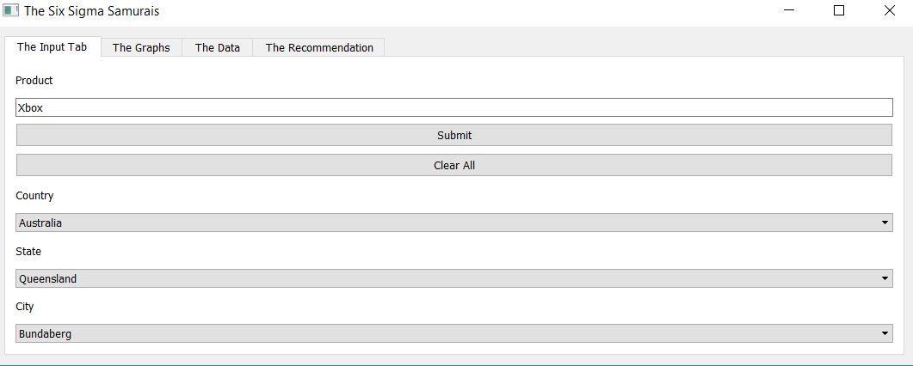

* The Graph tab to get the tab

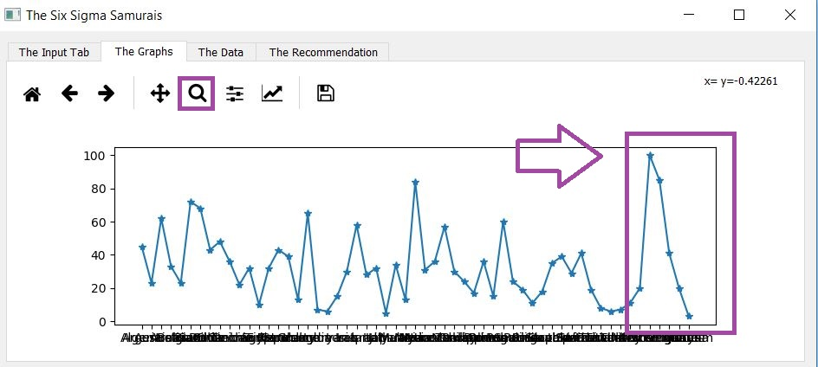

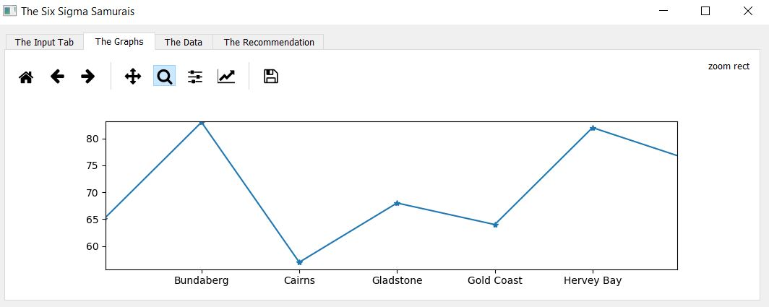

* To export the data to CSV:

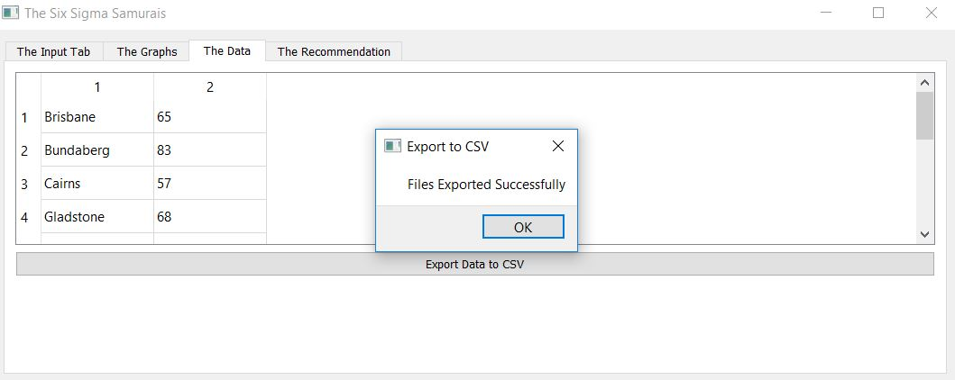

* The recommendation tab with population information and internet usage percentage

